
Totally Committed to Quality

THE EFFECTIVITY OF THIS DOCUMENT IS GUARANTEED ONLY BY VERIFICATION AGAINST THE ON-LINE EDMS DATA. THE USER MUST VERIFY ITS CURRENCY ON THE DAY OF USE.

Document Title
C07930 Vendor Specification and Configuration Instructions, Computer Assy, embedded, w/ OS & App, Vi-CELL BLU
Project Name
Hawkeye
Project Number
PC3527
Document Number
2.5.1.1-x
Document Version
0.10

Approver | Approve on date | Signature
Dennis Reilly
Troy Diaz

Content Summary

Document Title 2
1 Content Summary 3
2 Document Definitions 4
3 Document References 4
4 Introduction 4
5 Computer Assembly Specification 5
5.1 BIOS Settings 6
5.1.1 BIOS Settings Modifications 6
6 Computer Software Installations 7
6.1 Operating system Installation 7
6.2 Application Software Installation 8
7 Labelling Requirements 10
8 Additional Requirements 12

This document details the configuration requirements for a Hawkeye product family embedded single board computer. This part number includes instrument applications and is specific to the Scout compute platform assembly, “Computer Assy, embedded, with OS & App, Vi-CELL BLU” P/N C07930.

Document Definitions

- Table 2-1 - Definition of terms
Term | Definition
Hawkeye | Project name for the Vi-Cell instrument replacement family
Scout | Instrument name for the direct Vi-Cell replacement instrument
OS | Operating System
BIOS | Basic Input Output System; the firmware that provides the basic interface between an OS and the computer hardware on which the OS is running.
CMOS | Complimentary Metal-Oxide Semiconductor; a type of semiconductor used to produce low-power memory used in computers; the memory typically contains hardware configuration information used to control the startup and operation of computer hardware.

Document References

- Table 3-1 – Document references
Doc No. | Title
C08352 | Computer Assy, embedded, hi-performance, low power
C08363 | Win10 IoT OS Image w/ drivers, Vi-CELL instrument
C08360 | Hard Drive Assy, SSD, 500GB
C08365 | Application Set Assy, Vi-CELL BLU
C10358 | Assy, Vi-CELL BLU Application install/update, USB
C08356 | Assy, Hard Drive wWind 10 & Sys Apps, Vi-CELL BLU

Introduction
This document is the Specification to Beckman Coulter’s OEM Computer Integrator for the product titled “ Computer Assy, embedded, with OS & App, Vi-CELL BLU”, P/N C07930.
The embedded computer assembly contains the hardware, OS, supporting drivers, and instrument control application required by the Hawkeye Scout product. This part number is used on the Hawkeye Scout as the top-level control and data storage platform during instrument manufacturing.

Computer Assembly Specification
The product defined by this specification is a low-power general purpose computer with a form factor small enough to allow embedding in instruments for control and data storage use. The specific target for use of this computer assembly is the Hawkeye scout instrument.
The specification references the base computer, and calls out the OS image and the application software to be added.
The itemized specification follows:
Item | Description | Additional Information
 | C08352 - Computer Assy, embedded, hi-performance, low power | This is the base computer hardware
 | Modify BIOS settings from the default specified for C08352 per instructions below. See section on BIOS Settings Modifications. | Setting changes should be part of the “default settings” for this computer part number. This allows the user to restore the BIOS settings to the factory delivered state.
 | C08363 - Win10 IoT OS Image w/ drivers, Vi-CELL instrument. | - OS will be supplied as an image file-set to be loaded directly to the computer assembly SSD drive.  - OS image will be bootable for testing
 | C08360 - Hard Drive Assy, SSD, 500GB | - The base hard drive
 | C08365 - Application Set Assy, Vi-CELL BLU | Scout instrument application software set  - Application software may be provided on CD/DVD or USB media.
 | C10358 - Assy, Vi-Cell BLU Application Install/Update, USB | Scout instrument configured installation media  - Contains installable Application software from P/N C08365.
 | C08356 - Assy, Hard Drive w/ Win 10 & Sys Apps, Vi-CELL BLU | Scout Instrument hard drive assembly with OS, system drivers, and instrument application software
 | Label - Computer Manufacturer’s P/N, S/N and Manufacturer’s Identification label  This should be located on the ATX power input block of the motherboard, on the side adjacent to the motherboard edge. | Content is defined and controlled by OEM Computer Manufacturer.  Vendor Supplied
 | Label - Beckman Coulter Instrument Label  Label to Include:  - Beckman Coulter Logo  - Internal P/N: C07930  - Serial Number  See Sample Image below.  See below under Labeling Requirements for placement of this label. | Vendor specified and supplied.  Label may be printed monochrome if color is not available.
 | All items will be RoHS compliant.  Product and Packaging shall comply with Product Environmental Compliance Requirements as outlined in Beckman Coulter document A80946. | Vendor monitored and certified.  Vendor is required to provide a Certificate of Compliance along with delivery of the First Article for acceptance testing.
 | Must comply with RoHS labeling requirements.
 | Serial Number:  Each computer assembly must be uniquely serialized | Vendor Specified.
 | Warranty:  None. | Beckman Coulter does not require a warranty on computers.
 | Label - Package Label  Label to Include:  - Beckman Coulter Logo  - Internal P/N: C07930  - Computer Assy, embedded, with OS & Apps, Vi-CELL BLU  - Qty: 1  - Serial Number  - Date of Manufacture  - Country of Origin | Vendor specified and supplied.  Additional items that may appear on the label include any legal or regulatory required symbols or wording, e.g. WEEE, cRoHS, etc.  Label may be printed monochrome if color is not available.  If combined with the HIBC label, the Date of Manufacture does not need to be duplicated.  Requirements for this label may be changed by Beckman Coulter without the need to revise this specification document.
 | HIBC Label for packaged product:  - Beckman Coulter Logo and Name  - REF symbol: C07930  - SN symbol: Serial Number  - Mfg Date Symbol: Mfg Date  - Rev: A  - Qty: indicates the quantity in the shipping package. Shipping package may contain multiple articles, provided internal packaging contains only a single assembly per package, and provides the expected labelling.  - Primary HIBC barcode (Hxxx, C07930)  - Human readable code  - Secondary HIBC barcode (Serial Number)  - Human readable code  - Include Any Required Symbols  - Printed in USA | Vendor Specified and Supplied but meeting the requirements outlined in the “UPN Memo to Suppliers” available from Beckman Coulter.  Description may be shortened to occupy only one line.  Additional items that may appear on the label include any legal or regulatory required symbols or wording, e.g. WEEE, cRoHS, etc.  This label may be combined with the package label in 12 or applied as a separate label.  Requirements for this label may be changed by Beckman Coulter without the need to revise this specification document.

BIOS Settings
The base computer motherboard hardware shall be configured as specified for P/N C08352, which details the BIOS settings required for generic use of the computer platform.
The following section lists any modifications to the BIOS settings specified in the base computer assembly specification. Since the BIOS settings are organized by Tabs in the Setup Utility, the following is organized the same way. The information displayed is limited to only those items around the changed setting(s) and is provided only for context. A “->” in the left margin indicates a setting may differ from that of the base computer specification.
As in the Computer Assembly specification, items displayed in BOLD are selectable items; normal text is informational only. These changes define the desired state of the BIOS settings, but may already be met by the configuration of the base computer assembly.

BIOS Settings Modifications
No changes required.

Computer Software Installations
The following are the software installations to be applied to the base computer assembly, and the minimum verifications for performance.

Operating system Installation
The following instructions are extracted from the procedure to create BEC P/N C08358. That document should be the final reference where differences exist.
The tool for application of the image to the drive is the same tool used to create the OS image from a reference drive. Currently, the freeware product “Clonezilla” is used to generate the deliverable hard drive image and to apply the drive image to blank drives during subsequent system-drive build operations.
- The base operating system image from BEC is contained in BEC part number C08363 - Win10 IoT OS Image w/ drivers, Vi-CELL instrument.
  - The OS image on the reference media is supplied as a set of uncompressed files.
  - The installation media may be used for multiple installations, but should be checked periodically against the files from the reference image, if the installation media is not write-protected.
- If required, attach the base hard drive (BEC reference PN C08360 to the target computer assembly (BEC reference PN C08352).
- Plug the USB drive containing the disk imaging software into an available system USB port.
- Plug the USB drive containing BEC PN C08363 into an available system USB port.
- Reboot the system, and ensure the system boots to the imaging software.
- Configure the drive imaging software appropriately for applying a complete drive image.
- Apply the base operating system image from BEC part number C08363 to the hard drive, BEC P/N C08360, “Hard Drive Assy, SSD, 500GB”, following the procedure in the document for C08358.
- The created drive now represents BEC P/N C08358.
- Referencing the Backplane I/O Panel connector diagram below, connect a network cable to the LAN1 port (connector port ‘3’, closest to the HDMI and Display Port connectors).
- If the installation media was loaded from a CD/DVD drive, remove the drive before rebooting from the newly created drive.
- Apply power to the computer, and verify that the operating system boots and performs auto-login to a windows desktop screen.
- Logout of the default user auto-login, and login using the default administrative login.
- Through the control panel or other method, open the network configuration utilities and verify that ONLY the LAN1 port is active, and configured to use DHCP. The LAN2 port should indicate ‘disabled’. If not properly configured, refer to the BIOS settings of the base computer, PN C08352.

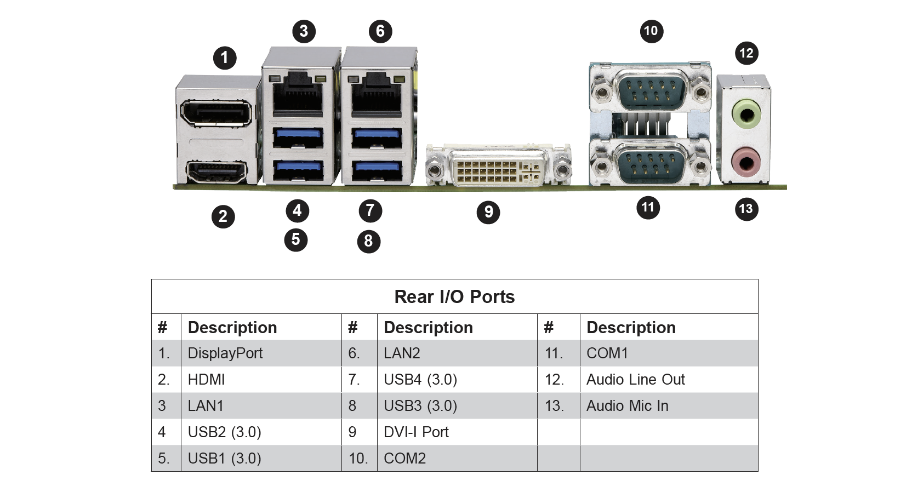

Application Software Installation
The following instructions are extracted from the procedure to create BEC P/N C08356. That document should be the final reference where differences exist.
- The CellHealth application software is contained in BEC part number C90104 – Application Set Assy, Vi-CELL BLU. The application software may be supplied on a CD/DVD or a USB drive. The application installer may contain a version number reference in the program name.
  - The application software image on the reference media is supplied as a single compressed, self-extracting file.
  - Installation media must be a USB flash drive.
  - If the application software is supplied on a CD/DVD, it must be transferred to a USB drive. Follow the steps below to create the installation media. ENSURE THAT THE USB DRIVE IS NOT THE APPLICATION SOFTWARE IMAGE SOURCE!
    - The USB drive to be used to create the application installation media (USB drive represents BEC reference P/N C10314) should formatted and assigned a drive volume label of C10358. No version number should be included.
    - After formatting the media, transfer the application software image to the prepared USB media.
    - The created USB installation media represents BEC P/N “C10358 Assy, Vi-Cell BLU Application Install/Update, USB”, supplied to fill service orders.
  - If the installation media is used for multiple installations and is not write-protected, it should be checked periodically against the reference image.

- Apply the application software installation to the system drive using the following steps:
  - Reboot/restart the system. The instrument user will automatically login to the standard instrument user. This user is a non-privileged user, and is not permitted to install software. Logout of the default instrument user, then login to the system using the administrative user id credentials provided separately.
  - Insert the USB flashdrive representing BEC PN C10358 into an available USB port.
NOTE: The system should recognize the USB drive and automatically mount the drive to a drive letter.
  - On the administrator’s desktop, locate the ‘Install ViCell Software’ shortcut, typically in the upper right area of the desktop. If the shortcut is present, proceed to step ‘h’ below.
  - If the ‘Install Software’ shortcut is not present, open a Windows File Explorer window to display the drive structure.
  - In the Windows File explorer window, locate the USB drive letter representing the drive inserted in step ‘b’ above. Confirm the presence of the installer file labelled C08365_vXXX.exe file on the installation media drive. Note that the filename format may differ slightly from the example, but the base name will contain the “C08365” name component as the initial name segment.
  - Use File Explorer to navigate to the “C:\Instrument” folder.
  - Locate the file “LoadViCell_Installer.bat”. Double click the file to begin the installation process.
  - A command window will open for the installation process.
  - When the initial steps of the installation process have copied necessary files, a secondary auto-extracting zip archive will be started. Accept the default extraction location when prompted, and allow the file extraction to proceed to completion.
  - When the extraction is complete, close the extractor window to allow the installation process to proceed.
  - A secondary installation process for the instrument UI will be started, and will display an installation progress dialog. No options are available. If necessary, select the ‘Next’ button to proceed with the secondary installation.
  - Allow the secondary UI installation process to complete. The main installation process will perform cleanup operations and, if no errors are encountered during the installation, the command window will close automatically. If no errors are indicated, proceed to step ‘n’ below.
  - If errors are encountered by the installation process, the command window will remain open to indicate that errors were detected. The details of any installation errors are located in the “C:\Instrument\Install.log” file. Note any errors, copy the log file for examination by BEC Engineering, and contact the BEC Engineering contact for assistance.
  - On successful installation, verify that the following file is present in the “C:\Instrument” folder:
    - C:\Instrument\ViCellBLU_UI.msi
  - Regardless of the success of the installation, ensure that the following files remain in the ‘C:\Instrument” folder:
    - C:\Instrument\LoadViCellInstaller.bat
    - C:\Instrument\find_installer.bat
    - C:\Instrument\carousel.ico
    - C:\Instrument\ViCellSplashScreen.jpg
    - C:\Instrument\BC_LS_Logo.jpg
    - C:\Instrument\ViCellDesktop.jpg
    - C:\Instrument\ViCellSplashScreen.jpg
    - C:\Instrument\ViCell-OS-vXX.YY.txt

- Remove the USB drive.
- The created drive now represents BEC P/N C08356.
- Using File Explorer, navigate to the “C:\Instrument\Software” folder and locate the ‘ViCellUI.exe.config’ file and the similar named ‘ViCellUi.exe.config.test’ and ‘ViCellUI.exe.config.hdwr’ files.
- Copy the file ‘ViCellUI.exe.config.test’ to the file name ‘ViCellUI.exe.config’ to make it the active UI configuration file. This will allow the UI to start without all instrument hardware present.
- Reboot the system, and verify that it boots directly to the Instrument control application screen similar to the one shown below (screen content may vary):

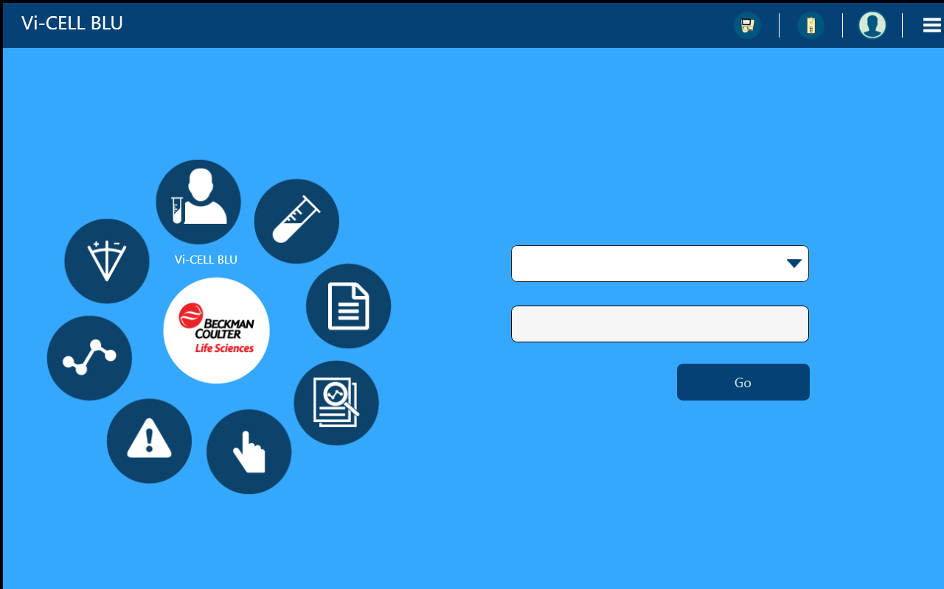

- If the system boots properly to the UI screen, exit the UI (using the ‘X’ button on the top bar, if present, or the ALT-F4 key combination to terminate the UI application.
- Using File Explorer, navigate to the C:\Instrument\Software folder and locate the ‘ViCellUI.exe.config.xxx’ files manipulated in the earlier step. Copy the file ‘ViCellUI.exe.config.hdwr’ to the file name ‘ViCellUI.exe.config’ to make it the active UI configuration file. This will configure the UI to start in the presence of instrument hardware, as is the expected condition.
- The created hard drive may be used for the creation of additional hard drive media.
- The vendor will create and maintain a build procedure for the creation of hard drives using a reference hard drive volume.

Labelling Requirements
Sample Image for Assembly Packaging Label: (Approximate size 1/2” x 2”)
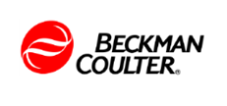
P/N: C07930
Reference: XXXXX

S/N: BCI011GF08714

An example of a combined package label with HIBC barcoding is shown below:

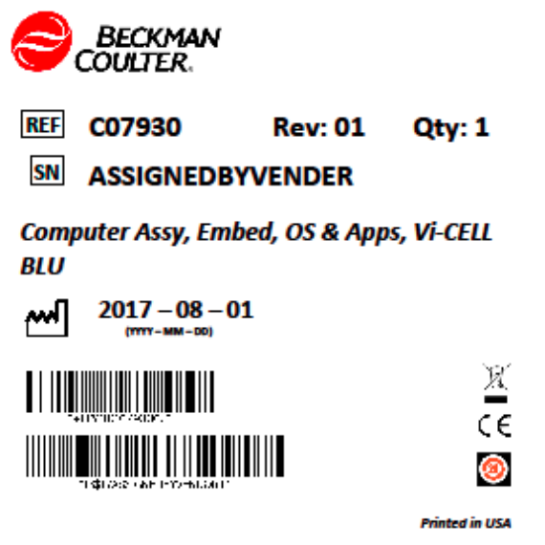

Notes on Assembly Packaging Label modifications:
The serial number shown on the sample labels is for illustrative purposes only and does not necessarily reflect the actual pattern or sequence of letters and numbers used in a real serial number. The reference number is optional, but if provided, should reference the vendor part number. Any included reference number should also appear on the shipping label.
Label may be printed monochrome if color is not available.
Image for locating Motherboard label:
Place the motherboard label on the side of the ATX power input connector block. Orient the labels so that it may be read looking at the side of the motherboard, with the top of the label near the top of the power connector block.
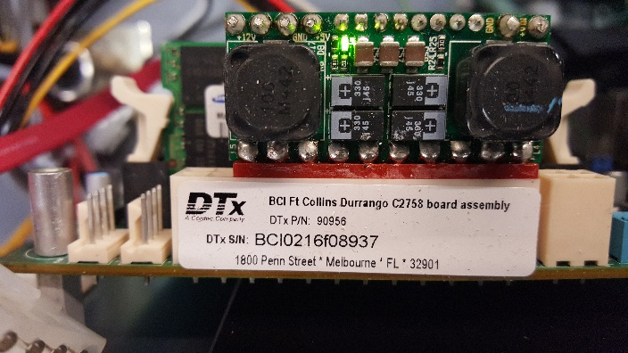
The information shown in the label image is for illustrative purposes only. The actual label should contain ONLY Beckman Coulter logos, part numbers, and Beckman Coulter-specific reference numbers.
Notes on Packaging Labels:
If the manufacturer needs to place reference information on the package, e.g. the manufacturer’s part number, or barcode, they may add a separate label on the package containing this information but it should not identify the manufacturer unless legally required. Any shipping label used is exempt from this requirement.

Additional Requirements
Beckman Coulter expects the vendor to create and control a build procedure for use within its manufacturing operation. This procedure must be made available to Beckman Coulter for inspection upon request.
The vendor will uniquely serialize each product and indicate this number on the instrument label, packaging label and HIBC label as specified above.
The vendor will provide Beckman Coulter a first article build of the product specified by this document for evaluation and acceptance.
All loose hardware, Recovery DVD or Flash drive, and China RoHS Material Declaration Insert should be placed in a box which is then secured inside the packaging for the computer.
Certification of RoHS Compliance must accompany the first article delivery.
Shipping Method:
Orders for C07930 may be shipped individually or combined on a pallet and shipped together to Beckman Coulter as long as the pallet contains only the C07930 part number.
These shipping requirements may be modified by Beckman Coulter purchasing in the future without the need to revise this document.

Change History

Author | Date | Description
Dennis Reilly | 02/15/2018 | Initial Version

